Chapter 19, Problem 84.

Using PSpice, find the transmission parameters for the network in Fig.19.126.

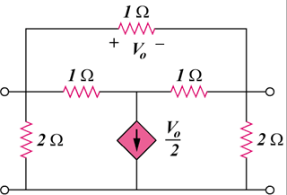

Figure 19.126
For Prob. 19.84.

